The Living Forest Trail Activity Guide

Directions: As you begin the trail start at the trail head, reflect on the first question, share your response with your classmate.

1. What can we gain from parks like Olympic National Park? What do you hope to gain by visiting here today?

2. Does there exist a right to parks? Do we have a right to public parks? Who’s responsibility is it to make it possible for parks to exist?

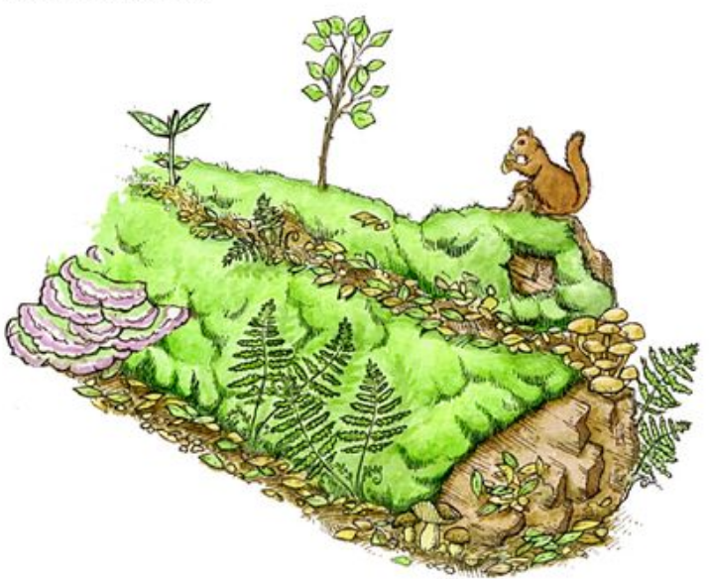
3. What is my role as an individual in the preservation of public places and public parks? Do I only have a role when I visit or in the park or do I have a role beyond the place and time of my visit?*

